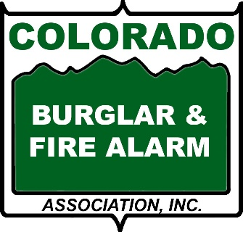
PROPER USE OF YOUR ALARM SYSTEM
It has been proven that user education is the best defense against false alarms. It is very important that the installer teach you and your family how to properly use your security system, including false alarm prevention measures. Everyone who will be using the system should be present during this educational process. To ensure your equipment will function properly in the event of an emergency, it is important to conduct regular testing on your systems.
Many municipalities are now charging fines for excessive false alarms. For this reason, you and anyone using the system should pay close attention to the instructions from the alarm company on system use.

TIPS TO PREVENT FALSE ALARMS
LOCAL ALARM ORDINANCES
Many municipalities have alarm ordinances requiring each home and business alarm to be registered. Call your local municipality for information on such an ordinance. These ordinances are in place so the police department will know who has an alarm.
Your alarm company will be able to assist you with the correct information about your local regulations.

