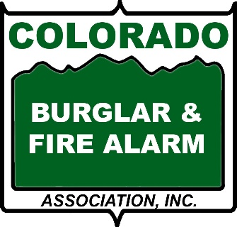
SELECTING AN ALARM COMPANY
Following are some tips for selecting a security alarm company:
- Visit CBFAA website at www.cbfaa.org. Here you can go to the Regular Member tab to find member companies in your area. Our member companies are properly licensed and must adhere to a strict Code of Ethics and Standard of Conduct which were put in place to protect consumers.
- Find a company with Certified Employees. When you speak with potential companies, ask them if their employees are trained by ESA's National Training School (NTS). Security professionals that are certified through NTS have completed extensive training in electronic security. Trained and certified professionals often yield more efficient and higher quality work than those who are not certified.
- One of the best ways to determine if an alarm company is credible is through consumer claims and work history. This information is readily available from several sources such as the crime prevention department at your local law enforcement offices, licensing agencies (such as Contractor’s Boards, city/county licensing, etc.) in your state, consumer protection agencies and the Better Business Bureau.
- Narrow the field to 3 companies. Arrange an appointment with each company when all members of your household will be present. Be sure to ask for the name of the person who will be calling on you. Upon the arrival of each representative, ask for proper company identification. Your consultation should consist of a home inspection and security recommendations for your property. Always ask for the quote for your alarm system in writing.
- You are establishing a relationship with the alarm company. Educate yourself so that you feel comfortable with your choice. Be sure the salesperson asks you what you want to protect and why as they are designing a solution around your needs.
- Study each contract to ensure you know exactly what you are getting. Consider the merits of leasing vs. buying.
- Know what company, if any, will be monitoring your alarm. Understand the procedures when an alarm is tripped and monitoring company calls.

LOCAL ALARM ORDINANCES
Many municipalities have alarm ordinances requiring each home and business alarm to be registered. Call your local municipality for information on such an ordinance. These ordinances are in place, so the police department will know who has an alarm.
Your alarm company will be able to assist you with the correct information about your local regulations. Some municipalities also charge fines for excessive false alarms, so be sure everyone who has access to the alarm knows how to properly use it.

